**Introduction:**

I am a native of Hsinchu. Many people say that Hsinchu is a **desert of delicacy** and there are no tourist attractions in Hsinchu, but I strongly disagree, so I will use this assignment to share the food and beauty of Hsinchu that I know.

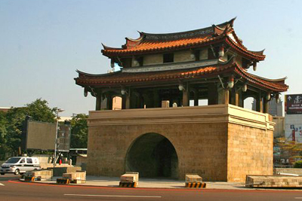

East door city(東門城)

**Task3: Use Hough transform to detect straight lines and cycles.**

A total of three tourist attractions images and three food image were used, and four image processing methods were used, namely:

1. Smoothing Filters
   1. Gaussian filter
2. Edge Detection
   1. Sobel filter
   2. Threshold
3. Hough transform for lines
4. Hough transform for cycles

**Preprocessing:**

1. Load images

Use python matplotlib api load images, and change images to array.

|  |  |  |
| --- | --- | --- |
| Nanliao Fishing Port  Fish scale ladder(魚鱗天梯) | Hsinchu Xiangshan  Voice of the Sea(海之聲) | Hsinchu Zhubei  Tofu Rock(豆腐岩) |
| Afu  Braised Pork Rice  (阿富 魯肉飯) | Xin Meizhen  Pudding Cake  (新美珍 布丁蛋糕) | C:\Users\user\AppData\Local\Microsoft\Windows\INetCache\Content.Word\meatball0.png  Shijia  Fish Ball  (石家 魚丸) |

1. Image grayscale

Use **Y' = 0.299 R + 0.587 G + 0.114 B**，change images from 3-dimension to 1-dimension。

|  |  |  |
| --- | --- | --- |
|  |  |  |
|  |  |  |

**Method detail**

1. Smoothing Filters

A. Gaussian filter

I use Gaussian filtering to reduce noise and increase σ to make the edges more obvious.

|  |  |  |
| --- | --- | --- |
| σ = 1 | σ = 1 | σ = 1 |
| σ = 1.3 | σ = 1.3 | σ = 1.2 |

1. Edge Detection
   1. Sobel filter

Use horizontal gradient、vertical gradient and ||+|| to detect edge.

|  |  |  |  |  |  |  |
| --- | --- | --- | --- | --- | --- | --- |
| -1 | 0 | 1 |  | -1 | 0 | 1 |
| -2 | 0 | 2 |  | -2 | 0 | 2 |
| -1 | 0 | 1 |  | -1 | 0 | 1 |

|  |  |  |
| --- | --- | --- |
|  |  |  |
|  |  |  |

* 1. Threshold

Normalize each image after the sobel filter to the range [0, 255], and set the threshold according to each image to clearly show the contour.

|  |  |  |
| --- | --- | --- |
| Threshold=40 | Threshold=40 | Threshold=75 |
| Threshold=50 | Threshold=50 | Threshold=70 |

3. Hough transform for lines

* 1. Create a cumulative matrix (ρ,θ), record the results of each ρ and θ, and accumulate 1 into the corresponding matrix position. We can use this cumulative matrix to get heatmap. The brighter the place, the more likely it is to be a straight line.

$$ρ= x*cos(θ)+y*sin(θ)$$

|  |  |
| --- | --- |
|  | Nanliao Fishing Port  Fish scale ladder(魚鱗天梯) |
|  | Hsinchu Xiangshan  Voice of the Sea(海之聲) |
|  | Hsinchu Zhubei  Tofu Rock(豆腐岩) |

* 1. Get the max value of cumulative matrix (ρ, θ), and use the (ρ, θ) to plot straight line.

|  |  |
| --- | --- |
|  | Nanliao Fishing Port  Fish scale ladder(魚鱗天梯) |
|  | Hsinchu Xiangshan  Voice of the Sea(海之聲) |
|  | Hsinchu Zhubei  Tofu Rock(豆腐岩) |

* 1. Delete the adjacent straight lines and keep the only straight line.

Compute every line the sum ρ+θ. If (ρ1+θ1) – (ρ2+θ2) < diff, only one of the straight lines is keep. The diff is a parameter. Use above function can reduce the number of straight lines.

|  |  |
| --- | --- |
|  | Nanliao Fishing Port  Fish scale ladder(魚鱗天梯)  It is a new attraction in Nanliao. Hsinchu has nine winds(九降風). You can play Windsurfing  and kites in that area. It is a tourist attraction suitable for families. |
|  | Hsinchu Xiangshan  Voice of the Sea(海之聲)  The Voice of the Sea is very close to the sea, and you can watch the wind turbines up close. It is a suitable place for couples to take. |
|  | Hsinchu Zhubei  Tofu Rock(豆腐岩)  Tofu Rock is a new attraction in Touqian Creek(頭前溪) in Hsinchu, which is famous for the wave-removing blocks that delay the deepening of the river bed, and are similar to blocks of tofu. Exception, the row of house prices on the river bank is the most expensive place in Zhubei. |

1. Hough transform for cycles
   1. Create a cumulative matrix (a, b, radius), record the results of each a, b, radius and accumulate 1 into the corresponding matrix position.
 $$a=x-r*\cos\left(θ\right)$$

 $$b=y-r*\sin\left(θ\right)$$

 2. Get the max value of cumulative matrix (a, b, radius), and use the (a, b, radius) to plot cycle.

|  |  |
| --- | --- |
|  | Afu  Braised Pork Rice  (阿富 魯肉飯) |
|  | Xin Meizhen  Pudding Cake  (新美珍 布丁蛋糕) |
|  | Shijia  Fish Ball  (石家 魚丸) |

* 1. Delete the adjacent cycle and keep the cycle.

|  |  |
| --- | --- |
|  | Afu  Braised Pork Rice  (阿富 魯肉飯)  Located next to the Chenghuang Temple(城隍廟), it is a simple dish that is super delicious with half-boiled eggs. |
|  | Xin Meizhen  Pudding Cake  (新美珍 布丁蛋糕)  Located in the alley of Xionglin(芎林), the aroma of the cake from the afternoon is very attractive. It is a must-eat ancient cake in Hsinchu. |
|  | Shijia  Fish Ball  (石家 魚丸)  Shijia Fish Ball is a 70-year-old store that insists on hand-making the freshest Hsinchu wrapped fish balls. |

**Result**

The food and beauty of Hsinchu will definitely not be lost to other regions, but there is no good publicity skills, and the government has not planned tourism facilities well. I hope that the most suitable tourist attractions in Taiwan in the future will be Hsinchu City's first place.

**Additional try**

I also use teacher’s image to try Hough transform for line and cycle. But the edge detected by the sobel filter is very rough. Maybe next time, I will use other edge detection methods, such as Canny algorithm to improve Hough transform.

|  |  |
| --- | --- |
|  |  |
| Threshold=70 | Threshold=100 |
|  |  |
|  |  |
| Threshold=90 | Threshold=40 |
|  |  |

**Code:**

Image preprocessing

A. load images

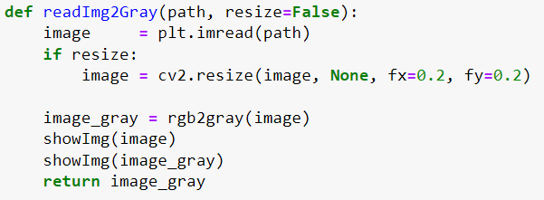

B. to gray

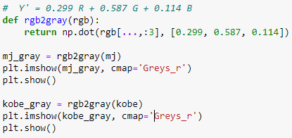

1. Smoothing Filters

A. Gaussian filter

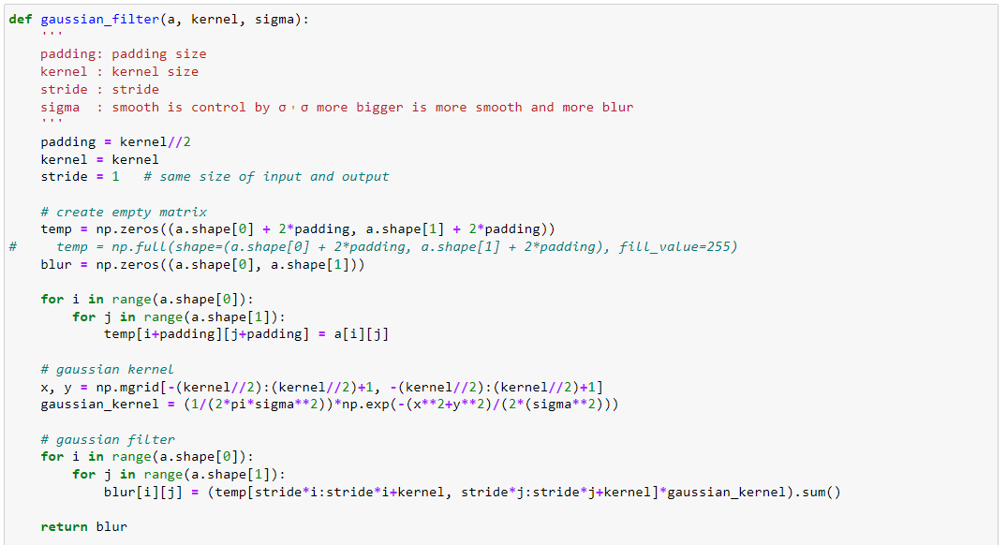

2. Edge Detection

1. Sobel filter

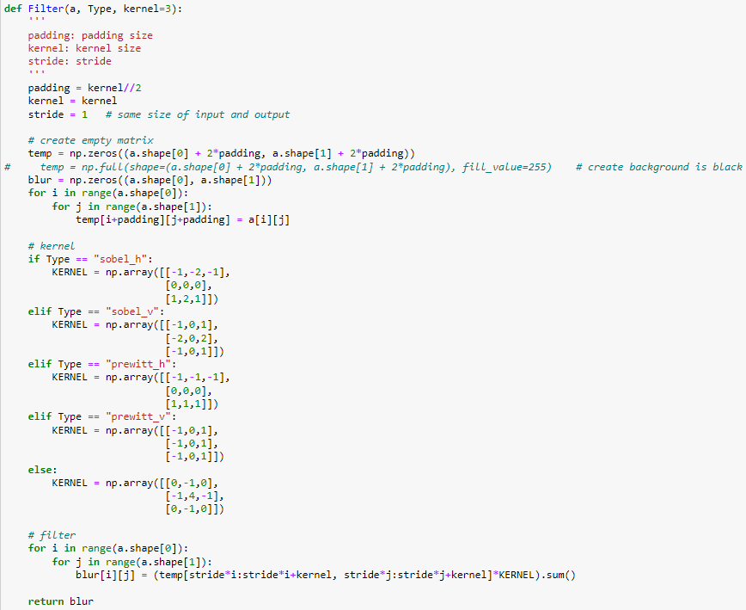



1. Threshold

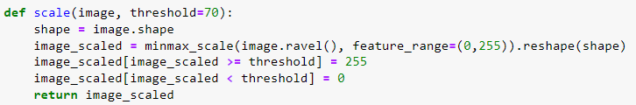

1. Hough transform for lines
2. Create a cumulative matrix (ρ,θ), record the results of each ρ and θ, and accumulate 1 into the corresponding matrix position.

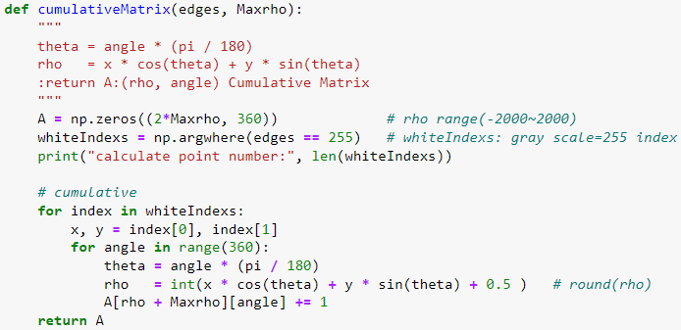

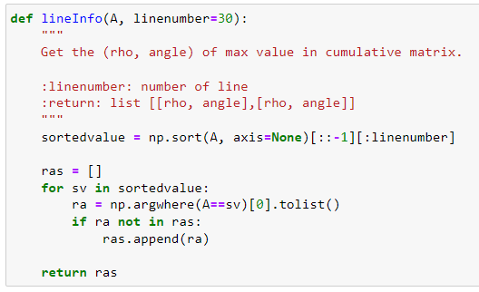

1. Get the max value of cumulative matrix (ρ, θ), and use the (ρ, θ) to plot straight line.

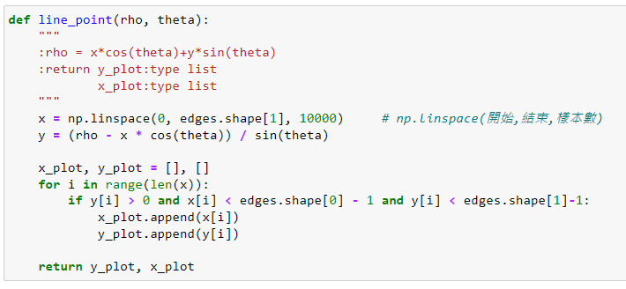

1. Delete the adjacent straight lines and keep the only straight line.

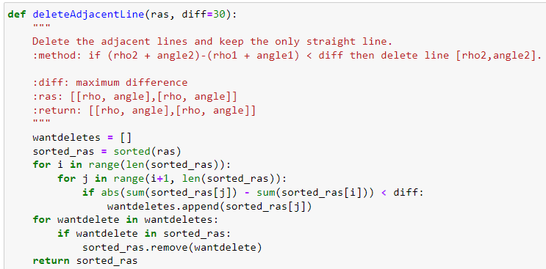

1. Hough transform for cycles
2. Create a cumulative matrix (a, b, radius), record the results of each a, b, radius and accumulate 1 into the corresponding matrix position.

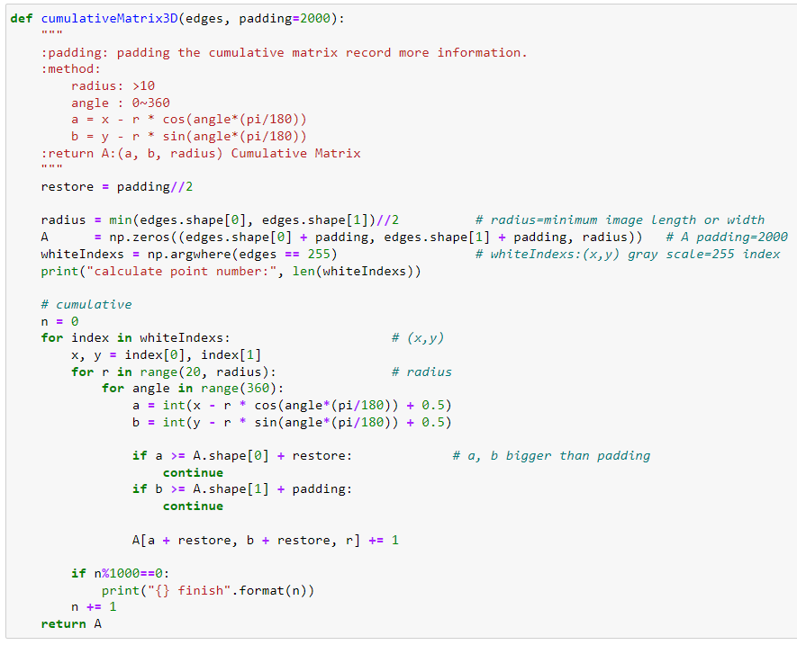

1. Get the max value of cumulative matrix (a, b, radius), and use the (a, b, radius) to plot cycle.

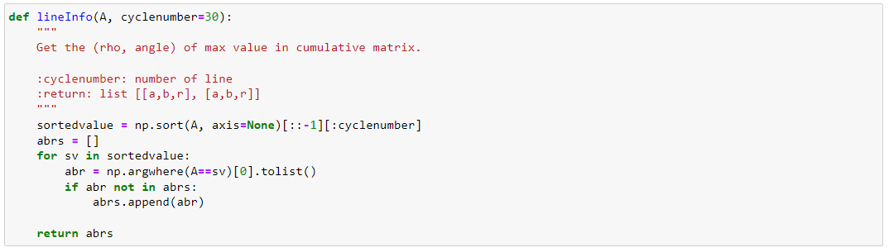

1. Delete the adjacent cycle and keep the cycle.

